

|  |  |
| --- | --- |
| **Student Name** | **Imaad Imran Hajwane** |
| **SRN No** | 202101132 |
| **Roll No** | 23 |
| **Program** | Computer Engineering |
| **Year** | Third Year |
| **Division** | A |
| **Subject** | DMPM – L [BTECCE 21608] |
| **Assignment No** | **6** |

**DMPM Lab Assignment:- 6_**Decision Tree

**Code:-**

library(arules) library(arulesViz) library(RColorBrewer) # Load data

data <- read.csv(choose.files()) View(data)

# (a) Minimum support = 1% and confidence = 30%

rules_a <- apriori(data, parameter = list(supp = 0.01, conf = 0.3)) # (b) Minimum support = 2% and confidence = 40%

rules_b <- apriori(data, parameter = list(supp = 0.02, conf = 0.4)) # (c) Minimum support = 3% and confidence = 50%

rules_c <- apriori(data, parameter = list(supp = 0.03, conf = 0.5)) # Display first 5 rules for each case

cat("First 5 rules for case (a):\n") inspect(rules_a[1:5])

cat("\nFirst 5 rules for case (b):\n") inspect(rules_b[1:5])

cat("\nFirst 5 rules for case (c):\n") inspect(rules_c[1:5])

# Sort all rules based on "lift" and display first 5 rules sorted_rules_a <- sort(rules_a, by = "lift") sorted_rules_b <- sort(rules_b, by = "lift") sorted_rules_c <- sort(rules_c, by = "lift") cat("\nFirst 5 rules sorted by lift for case (a):\n") inspect(sorted_rules_a[1:5])

cat("\nFirst 5 rules sorted by lift for case (b):\n") inspect(sorted_rules_b[1:5])

cat("\nFirst 5 rules sorted by lift for case (c):\n") inspect(sorted_rules_c[1:5])

# Interpretation of confidence value for two rules from each case cat("\nInterpretation of confidence value for two rules from case (a):\n") inspect(rules_a[1:2])

cat("\nInterpretation of confidence value for two rules from case (b):\n") inspect(rules_b[1:2])

cat("\nInterpretation of confidence value for two rules from case (c):\n") inspect(rules_c[1:2])

# Plot the rules

plot(rules_a, method = "graph", control = list(type = "items")) plot(rules_b, method = "graph", control = list(type = "items")) plot(rules_c, method = "graph", control = list(type = "items")) # Plot the rules using group method

plot(rules_a, method = "grouped") plot(rules_b, method = "grouped") plot(rules_c, method = "grouped")

# First 5 rules with minimum length 5 for case (a):

cat("\nFirst 5 rules with minimum length 5 for case (a):\n")

long_rules_a <- subset(rules_a, subset = length(lhs) >= 5 & length(rhs) >= 5) inspect(long_rules_a[1:5])

# First 5 rules with minimum length 5 for case (b):

cat("\nFirst 5 rules with minimum length 5 for case (b):\n")

long_rules_b <- subset(rules_b, subset = length(lhs) >= 5 & length(rhs) >= 5) inspect(long_rules_b[1:5])

# First 5 rules with minimum length 5 for case (c):

cat("\nFirst 5 rules with minimum length 5 for case (c):\n")

long_rules_c <- subset(rules_c, subset = length(lhs) >= 5 & length(rhs) >= 5) inspect(long_rules_c[1:5])

plot(rules_a)

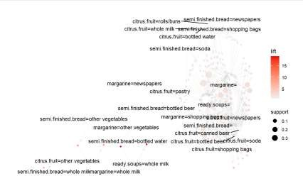

plot(rules-b)

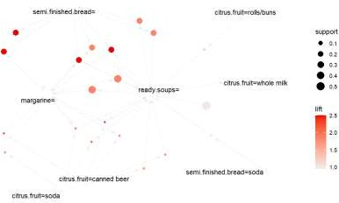

plot(rules_c)

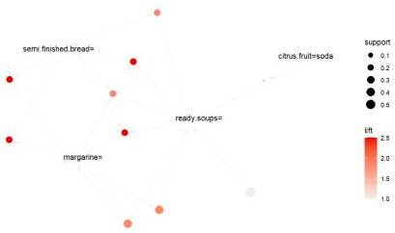

# Plot the rules using group method A)

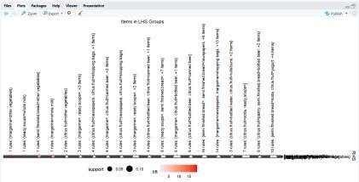

B)

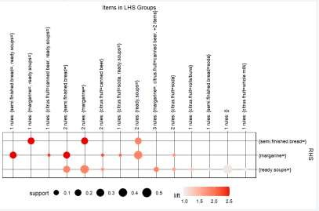

C)

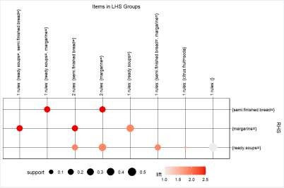

# First 5 rules with minimum length 5 for case (a):> cat("\nFirst 5 rules with minimum length 5 for case (a):\n")

First 5 rules with minimum length 5 for case (a):> long_rules_a <- subset(rules_a, subset = length(lhs) >= 5 & length(rhs) >= 5)> inspect (long_rules_a[1:5]) lhs rhs support confidence

1. {} => {margarine=} 0.39980386 0.3998039
2. {} => {ready.soups=} 0.53723439 0.5372344
3. {semi.finished.bread=newspapers} => {margarine=} 0.01157241 0.8894472
4. {semi.finished.bread=newspapers} => {ready.soups=} 0.01294541 0.9949749
5. {semi.finished.bread=bottled beer} => {ready.soups=} 0.01026479 0.7733990 coverage lift count

[1] 1.00000000 1.000000 6115

[2] 1.00000000 1.000000 8217

[3] 0.01301079 2.224709 177

[4] 0.01301079 1.852031 198

[5] 0.01327231 1.439593 157 > # First 5 rules with minimum length 5 for case (b):> cat("\nFirst 5 rules with minimum length 5 for case (b):\n")

First 5 rules with minimum length 5 for case (b):> long_rules_b <- subset(rules_b, subset = length(lhs) >= 5 & length(rhs) >= 5)> inspect (long_rules_b[1:5]) lhs rhs support confidence coverage

1. {} => {ready.soups=} 0.53723439 0.5372344 1.00000000
2. {citrus.fruit=canned beer} => {margarine=} 0.02262177 0.8917526 0.02536777
3. {citrus.fruit=canned beer} => {ready.soups=} 0.02451782 0.9664948 0.02536777
4. {semi.finished.bread=soda} => {ready.soups=} 0.02000654 0.6270492 0.03190585
5. {citrus.fruit=soda} => {margarine=} 0.02451782 0.6818182 0.03595946 lift count

[1] 1.000000 8217

[2] 2.230475 346

[3] 1.799019 375

[4] 1.167180 306

[5] 1.705382 375 > # First 5 rules with minimum length 5 for case (c):> cat("\nFirst 5 rules with minimum length 5 for case (c):\n") First 5 rules with minimum length 5 for case (c):> long_rules_c <- subset(rules_c, subset = length(lhs) >= 5 & length(rhs) >= 5)> inspect (long_rules_c[1:5]) lhs rhs support confidence

1. {} => {ready.soups=} 0.53723439 0.5372344
2. {citrus.fruit=soda} => {ready.soups=} 0.03059823 0.8509091
3. {semi.finished.bread=} => {margarine=} 0.22785224 1.0000000
4. {margarine=} => {semi.finished.bread=} 0.22785224 0.5699101
5. {semi.finished.bread=} => {ready.soups=} 0.22785224 1.0000000 coverage lift count

[1] 1.00000000 1.000000 8217

[2] 0.03595946 1.583869 468

[3] 0.22785224 2.501226 3485

[4] 0.39980386 2.501226 3485

[5] 0.22785224 1.861385 3485

